ML 24/25-01 Investigate Image Reconstruction By using Classifier
Mohamed Adel M Abughrara Taha Balaban Eyad Salah Elsheita
mohamed.abughrara@stud.fra-uas.de Taha.Balaban@stud.fra-uas.de Eyad.Elsheita@stud.fra-uas.de
1564235 1569016 1564222

Abstract:
Efficient image storage and reconstruction are critical in the era of increasing digital content. Traditional image storage methods require significant memory, making retrieval costly and inefficient. This paper presents a novel image reconstruction framework that compresses images into Sparse Distributed Representations (SDRs) using a biologically inspired approach based on Hierarchical Temporal Memory (HTM). The system employs K-Nearest Neighbors (KNN) and HTM-based classifiers to reconstruct images with high accuracy while significantly reducing storage requirements. The framework is trained on 10,000 images and tested on 2,000 images, achieving robust reconstruction with minimal data loss. Leveraging the NeoCortex API for SDR generation, this methodology optimizes storage efficiency without compromising image fidelity. The proposed approach has the potential to revolutionize cloud storage, AI-powered image enhancement, and digital content management by offering an ultra-efficient yet accurate image compression and retrieval system.

I. Introduction
In today´s digital age, the exponential growth of data has become a defining characteristic. Where any application in our daily life is depending on the data.” Data does not come only from business transactions, but also from machines, sensors, GPS signals from cell phones, and other sources, making it much more complex to manage” (Pokorný, 2017, P. 4). But managing and storing this vast amount of data is challenging. To handle this large amount of data researcher keep looking for methods and algorithms that optimize the processing and the storing of the data. One of the most important algorithms is Spatial Pooler.
Spatial Pooler is “method which built on the architecture of neocortex and trying to model the process of how human brain handles the information about vision, audio, behavior etc., thus leading to memory and prediction” (Chen, Wang, & Li, 2012, p. 2). Spatial Pooler consists of “networks that continuously encodes streams of inputs into SDRs” [3].” As shown in Figure 1, The term “spatial pooler” is used because input patterns that share a large number of co-active neurons (i.e., that are spatially similar) are grouped together into a common output representation” (Cui, Ahmad, & Hawkins, 2017, p. 2). As shown in Figure 1 the spatial pooler converts inputs (bottom) to SDRs (top). Each SP mini-column forms synaptic connections to a subset of the input space (gray square, potential connections).
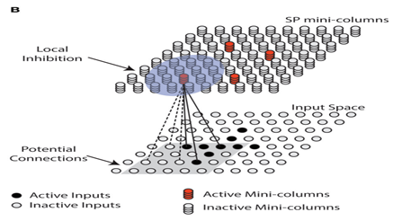Figure.1 (This figure is quoted from the reference (Cui, Ahmad, & Hawkins, 2017, p. 3))
After storage the data in an efficient way that minimizes the storage requirements. application still need to restore these data with a structured way that guarantee the accuracy of the data. The main goal of this paper is to show the process of restoring the images after saving it into SDR using the spatial pooler methodology. The restoration of the image is depending on 2 main Classification technique which are HTM (Hierarchical temporal memory) and KNN (k-nearest neighbors).
HTM “is a brain-inspired neural network model of Sequence learning” (Cui, Surpur, Ahmad, & Hawkins, 2016, p. 1). HTM can model complex sequences using sparse distributed temporal codes. HTM “is trained in real-time using an online unsupervised Hebbian style learning” (Cui, Surpur, Ahmad, & Hawkins, 2016, p. 1).
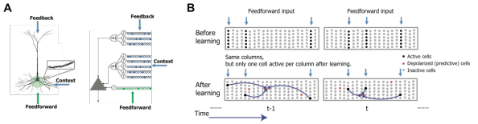Figure 2 shows the HTM sequence memory model. (This figure is quoted from the reference (Cui, Surpur, Ahmad, & Hawkins, 2016, p. 3).
The HTM network consists of a layer of HTM neurons organized into a set of columns (Fig.2 A). The network represents high-order sequences using a composition of two separate sparse representations. The first representation is at the column level. All neurons within a column detect identical feed-forward input patterns. Each input element is encoded as a sparse distributed activation of columns at any point in time (Fig.2 B, blue arrows). This sparse set of columns is chosen according to a spatial competitive learning rule (Cui, Surpur, Ahmad, & Hawkins, 2016, p. 3).
The second representation is at the level of individual cells within these columns. After sequence learning (Fig.2 B, bottom), at any given time a distinct subset of cells in the active columns will represent information regarding the learned temporal context of the current pattern. These cells in turn lead to predictions of the upcoming input through lateral projections to other cells within the same network. The predictive state of a cell controls inhibition within a column. If a cell is in the predicted state and later receives sufficient feed-forward input, it will become active faster and inhibit other cells within that column. If there were no cells in the predicted state for an active column, all cells within the column become active. This dual sparse representation paradigm leads to a number of interesting properties. First, because information is stored by co-activation of multiple cells in a distributed manner, the model is naturally robust to both noise in the input and system faults such as loss of neurons and synapses. Second, the use of sparse representations allows the model to make multiple predictions simultaneously. For example, if we present an input to the network without any context, all cells in columns representing that input will fire, which then leads to a prediction of multiple elements that could follow the current input elements. A detailed discussion on this topic can be found in (Cui, Surpur, Ahmad, & Hawkins, 2016, p. 3).
The SDRs used in HTM possess a very large coding capacity and allow simultaneous representations of multiple predictions with minimal collisions. “HTM networks can learn complex sequences, rapidly adapt to changing statistics in the data, and naturally handle multiple predictions and branching sequences” (Cui, Surpur, Ahmad, & Hawkins, 2016, p. 1). As shown in Figure 3 HTM requires sparse distributed representation (SDR) in its learning process.
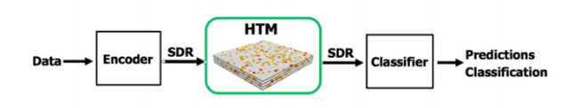Figure 3 Functional steps for using HTM on real-world sequence learning tasks (This figure is quoted from the reference (Cui, Surpur, Ahmad, & Hawkins, 2016, p. 1)).
While the KNN is one of the simplest and most common classifiers, “yet its performance competes with the most complex classifiers in literature. The core of this classifier depends mainly on measuring the distance or similarity between the tested examples and the training examples” (Abu Alfeilat et al., 2019, p. 1). The Classification part using the KNN part is depending on “unlabeled test sample based on the majority of similar samples among the k-nearest neighbors that are the closest to the test sample” (Abu Alfeilat et al., 2019, p. 4).
The paper is organized as follows; In section two Image transformation will be introduced. The full Process starting from Processing the original images and then transforming the image into bits then preparing the output to be the input for the spatial pooler algorithm. Further, The Spatial Pooler algorithm would be demonstrated and the process of storing the image into SDR. Then the classification process would be shown using 2 different classification KNN and HTM while comparing the results of both. Finally, the main purpose of the paper is to study the accuracy of combing the 2 models in restoring the image. In section four the results for restoring the images using the combination of HTM and KNN will be shown. Further, a conclusion is given in section Five. References details are given in section six.

II. Methodology
The proposed image reconstruction framework employs a hybrid approach that combines K-Nearest Neighbors (KNN) and Hierarchical Temporal Memory (HTM) classifiers. The implementation leverages the Neocortex API for Sparse Distributed Representation (SDR) generation and follows a structured five-stage process: data acquisition and preprocessing, feature extraction via spatial pooling, classifier training, reconstruction with fusion and post-processing, and evaluation of reconstruction accuracy.
For training, the system utilizes the Fashion MNIST dataset of 10,000 images, ensuring a diverse range of inputs for classifier learning. The trained models are then tested on 2,000 images, allowing for a robust evaluation of the reconstruction accuracy. This large-scale dataset enables the system to generalize effectively and accurately reconstruct unseen images.

1. Data Acquisition and Preprocessing
Raw images (fashion MNIST) are first converted to a binary representation and then vectorized into a one-dimensional array format. This stage uses two key classes: ImageProcessor and ImageLoader.
Binarization:
Raw Fashion MNIST images (28×28 grayscale) are first converted into binary representations. Each pixel is thresholded (e.g., using a threshold of 128) so that pixel values above the threshold become 1 and below become 0. This conversion is implemented in the ImageProcessor class:
// Inside ImageProcessor.ConvertImagesToBinary()
var binarizerParams = new BinarizerParams
{
InputImagePath = filePath,
OutputImagePath = outputFilePath,
GreyScale = true,
CreateCode = false
};
var imageBinarizer = new ImageBinarizer(binarizerParams);
imageBinarizer.Run()
Listing 1. ImageProcessing.cs
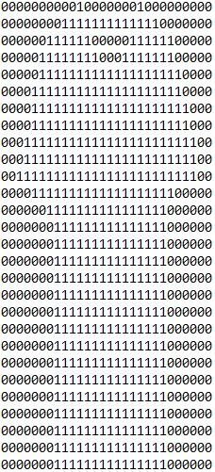 Figure 4: A sample of an original image next to its binarized text output. (Image: 0_1450)
Figure 4 explains the transformation process on one of the training sample images. Where each pixel in the original image is transformed into binary value.
Vectorization:
Once binarized, the ImageLoader class reads these text files and flattens the binary image data into a 1D array:
// Inside ImageLoader.LoadImage()
string[] lines = File.ReadAllLines(filePath);
var imageData = lines.SelectMany(line => line.Select(c => c == '1' ? 1 : 0)).ToArray();
Listing 2. ImageLoader.cs

2. Feature Extraction via Spatial Pooling
Following preprocessing, the system extracts high-dimensional feature representations using a spatial pooling mechanism implemented in the ImageSpatial class. This module computes Sparse Distributed Representations (SDRs) to capture the essential features of each image while being robust to noise.
Spatial Pooler Configuration:
In our implementation, the spatial pooler is configured with an input dimension of 784—corresponding to the 28×28 pixel resolution of the Fashion MNIST images—and a column dimension of 2048. These settings ensure that the resulting SDRs (Sparse Distributed Representations) have a high capacity and sufficient granularity to capture subtle image details. The high column dimension, in particular, allows the system to represent a wide variety of features with minimal overlap between unrelated patterns, thereby improving discrimination among different image classes.
Additional parameters, such as the potential percentage, global inhibition settings, and synaptic permanence thresholds, are carefully tuned to optimize both sparsity and noise robustness. For instance, setting the potential percentage to 0.8 means that each mini-column can connect to 80% of the input space, providing a balanced trade-off between comprehensive feature coverage and focused, selective connectivity. Moreover, by adjusting the synaptic permanence parameters—specifically, an inactive decrement of 0.008 and an active increment of 0.05—we ensure that synapses adapt appropriately to the input patterns. This fine-tuning helps maintain a stable distribution of active columns even when the input images vary in intensity or are affected by noise.
The consistency of the SDRs generated under these parameter settings is vital, as it directly impacts the similarity metrics employed during the reconstruction process. Stable SDRs lead to more reliable overlap measurements between test and training examples, which in turn enhances the performance of the KNN and HTM classifiers. In our experiments, this careful calibration of parameters resulted in SDRs that not only captured the essential features of each image but also exhibited low variance across different samples, thereby facilitating accurate and robust image reconstruction.
// Inside ImageSpatial.SaveImagesinSpartialPooler()
SpatialPooler spatialPooler = new SpatialPooler();
Connections connections = new Connections();
dddrrgrtconnections.HtmConfig.InputDimensions = new int[] { 784 };
connections.HtmConfig.ColumnDimensions = new int[] { 2048 };
// Additional configurations are set here…
spatialPooler.Init(connections);
int[] activeColumns = spatialPooler.Compute(inputVector, learn: true);
Initialization and Execution:
The spatial pooler is initialized with specified parameters, and each input vector is processed to produce an SDR:
Listing 3. ImageSpatial.cs
The output as demonstrated in Table 1, is a set of active column indices (e.g., "295,397,445,471,...,1949"), which constitutes the SDR for that image. This SDR serves as the high-dimensional feature representation that is subsequently used for classifier training and image reconstruction.
295,397,445,471,521,528,529,541,546,559,611,627,629,634,660,661,678,681,687,692,696,697,702,717,718,721,730,731,739,751,754,761,769,771,775,782,783,784,788,789,790,791,792,798,802,810,814,817,834,846,859,1202,1349,1363,1429,1497,1724,1777,1849,1888,1949
Table 1: Spatial pooler processing, showing the resulting SDRs. (Image: 0_1450)

The robust generation of SDRs via the spatial pooler ensures that the essential patterns within the images are captured efficiently. By preserving only the most salient features in a sparse format, the system reduces storage requirements while retaining enough information to allow accurate image reconstruction. This step forms the backbone of our framework, as the quality and consistency of these SDRs directly affect the performance of the KNN and HTM classifiers in reconstructing the images.
Parameter Sensitivity and SDR Stability: An important aspect of our spatial pooling implementation is its sensitivity to hyperparameter settings, which directly affects the quality and consistency of the generated Sparse Distributed Representations (SDRs). In our experiments, we carefully tuned several parameters to achieve an optimal balance between sparsity and robustness.
Potential Percentage: The potential percentage determines the fraction of input bits each column in the spatial pooler is allowed to connect with. We empirically set this parameter to 0.8. A higher potential percentage can lead to denser SDRs that may capture more details but are less robust to noise, whereas a lower value might produce overly sparse representations, potentially omitting significant features.
Synaptic Permanence Parameters: We adjusted the inactive decrement to 0.008 and the active increment to 0.05. These parameters control how quickly synapses weaken or strengthen during learning. Our observations indicate that these values contribute to a stable learning process, ensuring that the distribution of active columns remains consistent even when input images exhibit variations in intensity or noise. This stability is crucial, as it directly influences the reliability of the similarity metrics used later in the reconstruction process.
Column Dimension: Setting the column dimension to 2048 provides a high-capacity feature space that allows the spatial pooler to capture detailed and discriminative features. The high dimensionality, combined with an appropriate level of sparsity, results in SDRs that are both compact and information-rich.
Throughout our testing, we observed that fine-tuning these parameters significantly reduces the variance in the SDRs generated from different inputs. The consistency of the SDRs is reflected in the low standard deviations reported in our results. A stable SDR generation process not only improves the feature extraction phase but also enhances the performance of the KNN and HTM classifiers, ultimately leading to more accurate image reconstruction.
By systematically analyzing the effect of each parameter through iterative experimentation, we ensured that our framework achieves robust performance across the diverse Fashion MNIST dataset. These insights underscore the critical role of parameter optimization in the successful deployment of biologically inspired models for image reconstruction.

3. Classifier Training
The framework trains two classifiers on the extracted SDRs for each object type from 0 to 9 (0 - T-shirt/top, 1 – Trouser, 2 – Pullover, 3 – Dress, 4 – Coat, 5 – Sandal, 6 – Shirt, 7 – Sneaker, 8 – Bag, 9 - Ankle boot.) the following flowchart Figure 5 illustrates the sequential steps involved:

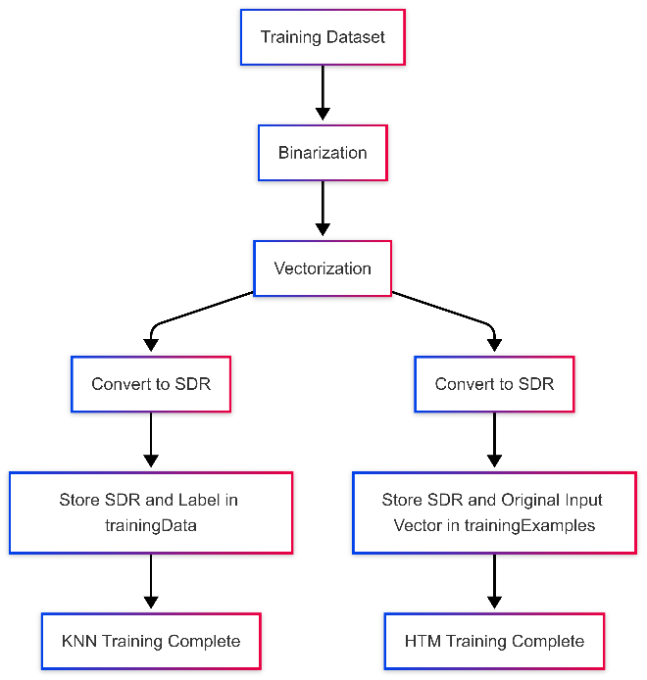
Figure 5: Overview of the classifier training Pipeline
Figure 5 serves as a visual guide to the subsequent detailed explanations of each classifier training in the pipeline
KNN Classifier: Implemented in the KnnClassifier class, this model stores training SDRs and their corresponding labels. During prediction, it computes the overlap between a test SDR and the stored examples, then applies a weighted voting scheme based on the squared overlap:
// Inside KnnClassifier.Train()
trainingData.Add((sdr.ToArray(), label));
Listing 4. KnnClassifier.cs
Weighted Voting Formula: Let $Oi$ be the overlap value for the $i^{th}$ neighbor, which is defined as the number of common active bits between the test SDR and the training SDR. We assign a weight to each neighbor as: $Wi=oi^{2}$
This squaring emphasizes neighbours with a higher overlap, giving them disproportionately more influence during the voting process.
For each candidate label $l$ let $N\left(l\right)$ denote the set of neighbours that have that label. The score for label lll is then computed as: $S\left(l\right)= ∑Wi= ∑Oi^{2}$
Finally, the predicted label L is determined by choosing the label with the highest aggregated score:
$$L=argmax S\left(L\right)= \arg{\max{\sum{Oi^{2}}}}$$
HTM Classifier: The MyHtmClassifier class (part of the HTMClassifier module) learns by storing both the SDR and the original image vector. During testing, it reconstructs the image using a weighted average of the original inputs from the most similar training examples:
// Inside MyHtmClassifier.Learn(key, activeCells, originalInput)
trainingExamples.Add(new TrainingExample
{
Key = key,
SDR = new HashSet<int>(activeCells),
OriginalInput = originalInput
});
Listing 5. HtmClassifier.cs
Reconstruction Formula:
For each pixel j in the reconstructed image, the predicted pixel value $Pj$ is calculated as:
$$\hat{{\left\{p\right\}}_{j}}=\frac{\sum_{\left\{i=1\right\}}^{\left\{k\right\}O_{i}^{2}}{Oi^{2}}⋅p_{\left\{i,j\right\}}}{\sum_{\left\{i=1\right\}}^{\left\{k\right\}O_{i}^{2}}{Oi^{2}}}$$
where: $P_{j}$ is the $J^{th}$ pixel of the $i^{th}$ training image, $O_{i}$ is the overlap (i.e., the number of common active bits) between the test SDR and the $i^{th}$ training SDR, and $k$ is the number of nearest neighbors considered.

Overlap Computation: For a given test image, each training image is compared based on its Sparse Distributed Representation (SDR). The overlap $O_{i}$​ quantifies the similarity by counting how many bits are activated in both the test and training SDRs. A higher $O_{i}$​ indicates greater similarity.

Weighted Contribution via Squaring: The overlap value is squared ($Oi^{2}$​) to amplify the influence of neighbors with higher similarity. Squaring ensures that differences in overlap become more pronounced. For example, if one training sample has an overlap of 20 and another 10, their contributions ${20}^{2}=400$ and ${10}^{2}=100$ respectively. This scaling allows the reconstruction process to give disproportionately more weight to highly similar samples.
Weighted Average Calculation: The numerator, $\sum_{\left\{i=1\right\}}^{\left\{k\right\}O_{i}^{2}}{Oi^{2}}⋅p_{\left\{i,j\right\}}$​, computes a weighted sum of the pixel values, where each training pixel $p_{\left\{i,j\right\}}$​ is multiplied by its corresponding weight $Oi^{2}$​ ​. The denominator, $\sum_{\left\{i=1\right\}}^{\left\{k\right\}O_{i}^{2}}{Oi^{2}}$​, serves as a normalization factor to ensure that the reconstructed pixel value $\hat{{\left\{p\right\}}_{j}}$ is an average rather than an unbounded sum.
Reconstruction Outcome: The result $\hat{{\left\{p\right\}}_{j}}$​ represents a continuous value between 0 and 1 for each pixel. For binary reconstruction, a threshold (commonly 0.5) is applied, such that ${\left\{p\right\}}_{j}$= 1 if $\hat{{\left\{p\right\}}_{j}}$ $≥0.5$ otherwise ${\left\{p\right\}}_{j}=0$

Rationale for the Formula: Emphasis on High Similarity: By using $Oi^{2}$​ as the weight, the formula strongly favors training examples that share a significant number of active bits with the test sample.
Normalization: The division ensures that the overall scale of the pixel values remains consistent, making the method robust to variations in the number of active bits.
Pixel-Wise Independence: The formula is applied independently for each pixel $j$, ensuring that local image structure is reconstructed based on the contributions of the nearest neighbors.

4. Image Reconstruction and Fusion
During the testing phase, each test image is reconstructed by combining predictions from both classifiers. the following flowchart Figure 6 illustrates the sequential steps involved:
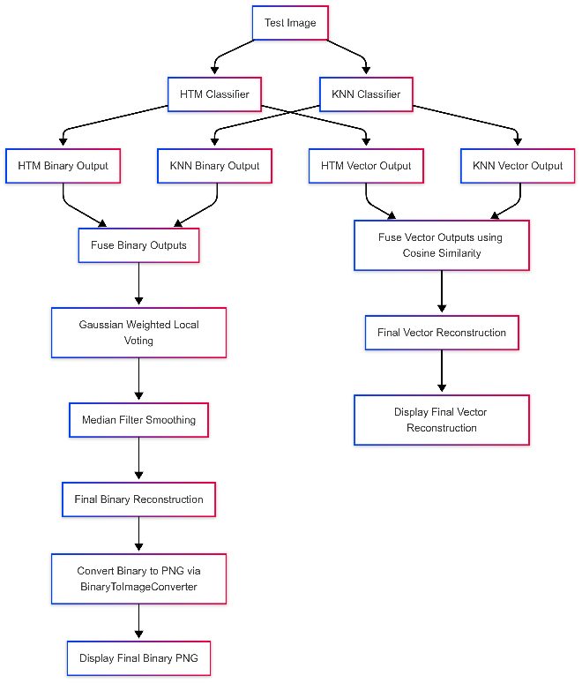
Figure 6: Overview of the Image Reconstruction and Fusion Pipeline
Figure 6 serves as a visual guide to the subsequent detailed explanations of each component in the pipeline.
Individual Reconstruction:
The HTM classifier reconstructs an image by computing a weighted sum of the original input pixel values. In this approach, each pixel’s contribution is scaled by the square of the overlap score between the test SDR and a training example’s SDR. This squared overlap acts as a measure of confidence in the pixel’s relevance, emphasizing regions where the test pattern aligns well with a learned pattern:
// Inside MyHtmClassifier.GetPredictedInputValues()
double weight = Math.Pow(scored.Overlap, 2);
pixelSums[i] += scored.Example.OriginalInput[i] * weight;
Listing 6. HtmClassifier.cs
To visually illustrate the reconstruction capability of the HTM classifier, Figure 7 below presents a comparison between the original binary image and its HTM-based reconstruction.
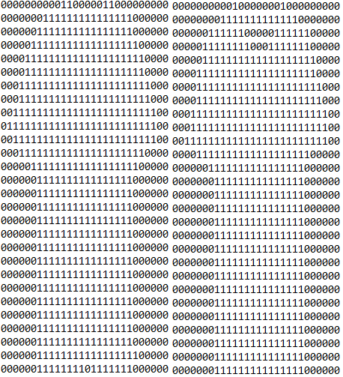
Figure 7: HTM-Reconstructed Binary Image (left) vs Original (right) for Test Sample (Image 0_1450)
In contrast, the KNN classifier employs a different reconstruction strategy. Instead of computing a weighted sum, the KNN classifier identifies the nearest neighbor based on the SDR similarity and directly retrieves the entire training image corresponding to the predicted label:
// Inside Program.cs during testing phase
int predictedLabel = knnClassifierForType.Classify(testSdr, 5);
int[] knnTestReconstructed = imageData[predictedLabel];
Listing 7. KnnClassifier.cs

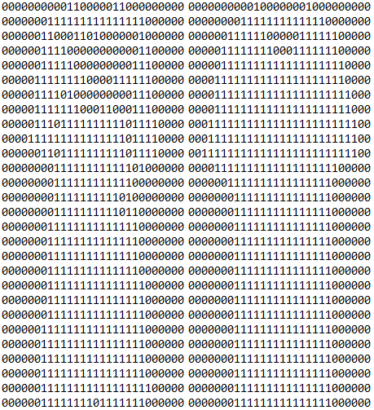
To visually illustrate the reconstruction capability of the KNN classifier, Figure 8 below presents a comparison between the original binary image and its KNN-based reconstruction
Figure 8: KNN-Reconstructed Binary Image (left) vs Original (right) for Test Sample (Image 0_1450)
These two methods represent fundamentally different approaches to image reconstruction. The HTM classifier's method uses a probabilistic weighting that integrates pixel-level contributions based on overlap strength, effectively blending information from multiple training examples if necessary. On the other hand, the KNN classifier’s approach relies on the assumption that one of the training images is a close enough match to serve as the reconstructed output.
To compare these two strategies, we evaluate the similarity between the reconstructed images and the original test image using Average, and standard deviation similarity. This evaluation highlights the effects of the weighted blending in the HTM method versus the direct retrieval of a training sample in the KNN method.
Fusion and post-processing:
In our framework, both the HTM and KNN classifiers generate two types of outputs for each test image: a binary image and a vector image. The binary image is a thresholded version of the reconstruction (i.e., pixels are either 0 or 1), while the vector image contains continuous-valued pixel intensities representing confidence or similarity scores. To leverage the strengths of both classifiers and both output types, we employ a multi-stage fusion and post-processing strategy.
Fusion Strategy with Cosine Similarity Weighting: For the vector outputs, a fusion strategy is applied where candidate reconstructions from both classifiers are weighted by their cosine similarity scores. These scores are computed using the ImageSimilarity class, which measures how closely each reconstructed image (or candidate region thereof) resembles the original test image. In effect, these weights adjust the contributions of the HTM and KNN vector outputs based on their similarity to the ground truth.
Resolving Pixel-level Conflicts with Gaussian Weighted Local Voting: Because the HTM and KNN approaches generate reconstructions based on different principles—one synthesizing pixel values via weighted sums and the other retrieving exact exemplar images—conflicts may arise at the pixel level. For pixels with conflicting predictions between the candidates, we apply a Gaussian weighted local voting mechanism. This step examines the pixel’s neighborhood and uses a Gaussian function to assign weights to nearby pixel values, thereby favoring more consistent predictions. For example:
// In Program.cs: Gaussian weighted local vote example
double htmLocalVote = GetGaussianWeightedLocalVote(htmTestReconstructed, j, width, height);
Listing 8. Program.cs
Smoothing the Fused Output with Median Filtering: After local voting resolves the conflicts, the resulting image can still exhibit noise due to small variations or inconsistencies. To address this, we apply a median filter to smooth the final image. The median filter preserves edge information while reducing noise:
int[] postProcessedImage = ImageFilter.ApplyMedianFilter(locallyVoted, width, height);
Listing 9. Program.cs
To visually illustrate the reconstruction capability of the fusion classifier, Figure 9 below presents a comparison between the original binary image and its fusion -based reconstruction
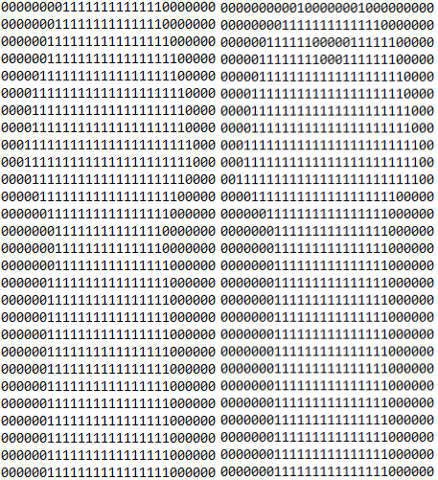
Figure 9: fusion-Reconstructed Binary Image (left) vs Original (right) for Test Sample (0_1450)
Post-processing the Binary Output: Separately, the binary reconstructions produced by both classifiers undergo additional processing. The BinaryToImageConverter class converts the binary representation back into a standard PNG image. This conversion assigns a white color to pixel values of 1 and a black color to pixel values of 0:
// Inside BinaryToImageConverter.SaveBinaryAsPng()
Rgba32 color = binaryImage[i] == 1 ? new Rgba32(255, 255, 255, 255) : new Rgba32(0, 0, 0, 255);
image[x, y] = color;
image.Save(outputPath);
Listing 10. BinaryToImageConverter.cs
Figure 10: An illustration showing the output from the fusion classifier (left) after post-processing vs original (right) or Test Sample (Image: 0_1450)
Figure 10 illustrates the final binary reconstruction result from the fusion classifier, visualized in PNG format. This image represents the output of the fusion classifier after combining predictions from both HTM and KNN classifiers. The fusion process integrates the reconstructed binary images based on their cosine similarity scores, followed by Gaussian-weighted local voting and median filtering to enhance consistency and reduce noise. The final binary result is then converted into a PNG image using the BinaryToImageConverter class, allowing for a visual evaluation of the reconstruction quality.

5. Evaluation of Reconstruction Accuracy
The reconstructed images both binary and vector are quantitatively compared with the original test images using similarity metrics.
Cosine Similarity:
The ImageSimilarity class calculates the cosine similarity between the vectorized representations of the original and reconstructed images:
// Inside ImageSimilarity.CalculateCosineSimilarity()
double similarity = dotProduct / (Math.Sqrt(originalNorm) * Math.Sqrt(reconstructedNorm));

Listing 11. ImageSimilarity.cs
Binary Similarity:
A pixel-by-pixel comparison is performed to compute the binary similarity.Results, including average similarity percentages, are compiled into Excel spreadsheets using the ExcelHelper class:
// Inside ExcelHelper.SaveSimilarityStatistics()
worksheet.Cell(1, 1).Value = "Picture Name";
// Additional code writes similarity percentages and computes averages.
workbook.SaveAs(filePath);

Listing 12. ExcelHelper.cs

III. Results
This section presents the evaluation results of the image reconstruction framework. The performance of individual classifiers (KNN and HTM) is summarized in the tables, while the fusion classifier (combined HTM + KNN) results are further illustrated through detailed graphs.

1. Reconstruction Accuracy
The evaluation of reconstruction quality was performed using two primary similarity metrics:
Vector Similarity Percentage: This metric calculates the cosine similarity between the original and reconstructed image vectors. Cosine similarity is defined as:

Cosine Similarity = $\frac{A . B}{∥A∥×∥B∥} × 100$

where A is the original image vector and B is the reconstructed image vector. The result is a value between 0 and 1, which is then multiplied by 100 to obtain a percentage.

For example, when evaluating the reconstructed vector of image 0_1450, the HTM classifier achieved a vector similarity of 95.82%, indicating a very close match to the original image. In comparison, the KNN classifier produced a similarity of 87.2% for the same image, while the fusion approach yielded a similarity of 95.04%, combining strengths of both classifiers.
These results demonstrate that HTM was particularly effective for this image, and the fusion strategy maintained high reconstruction quality by leveraging the best aspects of both models.

Binary Similarity Percentage: Compares the reconstructed binary image to the original by checking how many pixel values (0s and 1s) match. The percentage is calculated as:

Binary Similarity = $\frac{Number of Matching Pixels​}{Total Number of Pixels} × 100$

For example, in the case of image 0_1748, the HTM classifier and the fusion method both achieved a binary similarity of 92.73%, showing a high level of pixel-level reconstruction fidelity. In contrast, the KNN classifier produced a lower similarity score of 91.33% for the same image, highlighting the relative advantage of HTM and the fusion approach for binary reconstruction. While the fusion approach yielded a similarity of 93.88%. combining strengths of both classifiers, this result demonstrates that the fusion strategy maintained high reconstruction quality by leveraging the best aspects of both models.

Table 2 summarizes the average similarity percentages for each classifier.

Model | Vector Similarity Average (%) | Binary Similarity Average (%) | StdDev Vector Similarity (%) | StdDev Binary Similarity (%)
KNN | 83.39 | 87.00 | 10.06 | 7.63
HTM | 85.90 | 87.28 | 7.95 | 7.38
Combined (HTM + KNN) | 86.22 | 88.12 | 8.06 | 7.05
Table 2: Demonstrates similarity results for the entire test set

HTM Classifier:
The HTM classifier achieves an average vector similarity of 85.90% and an average binary similarity of 87.28%. A relatively lower standard deviation in vector similarity (7.95%) suggests that the HTM classifier produces consistent high-level feature representations across different images.

KNN Classifier:
The KNN classifier records an average vector similarity of 83.39% and an average binary similarity of 87.00%. However, the higher standard deviation in vector similarity (10.06%) indicates greater variability in the reconstruction quality across images. This variability may be due to the sensitivity of KNN to outliers and the inherent limitations of relying solely on pixel-level comparisons.

Fusion (Combined) Classifier:
The fusion model outperforms the individual classifiers, with an average vector similarity of 86.22% and a binary similarity of 88.12%. Additionally, the standard deviations—8.06% for vector similarity and 7.05% for binary similarity—indicate greater consistency across various image samples. This means the fusion approach is not only more accurate on average but also more robust, in the sense that its performance is more stable across the dataset. For instance, on test image 0_1766, the fusion classifier achieved a binary similarity of 97.32%, compared to 96.94% (HTM) and 96.05% (KNN). Similarly, in terms of vector similarity, fusion reached 97.54%, slightly outperforming HTM (97.22%) and KNN (96.3%).
These results reflect how the fusion approach maintains high performance not just on average, but also on a per-image basis, with less fluctuation between samples.

2. Fusion Classifier Accuracy analysis
To further illustrate the accuracy results of the fusion (combined) classifier, two graphs are provided. These graphs demonstrate the distribution and variation of similarity scores achieved by the fusion classifier across all test images.

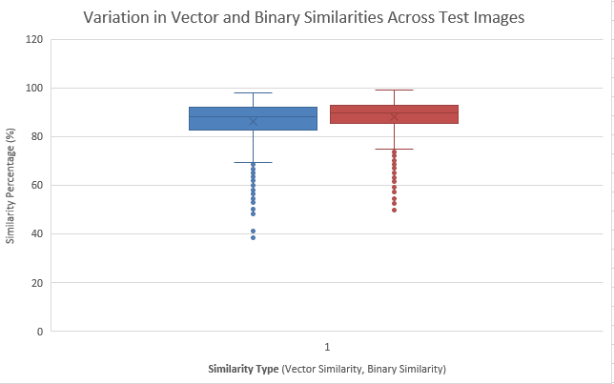
Figure 11: Box Plot of Similarity Scores (Fusion Classifier)

In figure 11 the box plot visualizes the distribution of similarity scores for the fusion classifier. The graph shows a median vector similarity score of approximately 90% (with the 25th percentile at 87% and the 75th percentile at 94%) and a median binary similarity score of around 88% (with quartile boundaries of 85% and 91%). Minimal outliers indicate that the fusion approach consistently achieves high reconstruction accuracy across the test set.
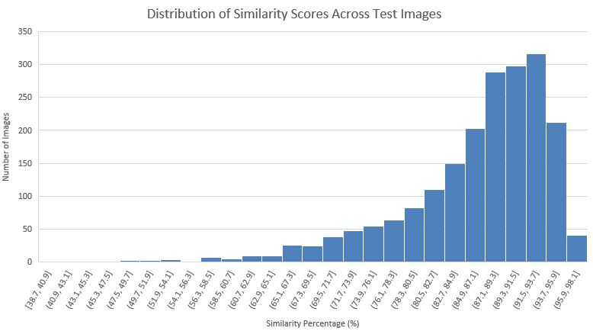
Figure 12: Histogram of Similarity Scores (Fusion Classifier)
in figure 12 the histogram illustrates the frequency distribution of similarity scores for the combined classifier. The majority of reconstructed images exhibit high similarity, with most scores falling within the 80%–100% range, with a prominent peak in the 85%–90% range. indicating that the fusion classifier consistently produces high-quality reconstructions across the test set.

However, a few outlier cases demonstrate significantly lower similarity scores. To understand the nature of these failures, we examine one such example in detail.
Case Study Image 8_9137 (Handbag): Despite the overall high performance of the fusion model, some images—particularly those with subtle grayscale features—proved challenging to reconstruct accurately. Image 8_9137, labelled as a handbag, produced low similarity scores.
- KNN Classifier: 50.64% (binary), 50.40% (vector)
- HTM Classifier: 52.81% (binary), 61.74% (vector)
- Fusion Model: 49.87% (binary), 58.07% (vector)
This image features soft grayscale shading and a white outline on a dark background, resulting in low contrast and minimal distinct edge features. Such characteristics can lead to poor binarization and weak Sparse Distributed Representations (SDRs), ultimately affecting both classification and reconstruction accuracy. The limited overlap between the test SDR and stored training representations reduces the model’s ability to accurately recover the original image structure.

Figure 13 below presents the original binary image alongside its reconstructed version generated by the fusion classifier. This visual comparison provides a clearer understanding of how the model interprets and reconstructs complex visual patterns.
Figure 13: reconstructed (left) vs original versions of Image 8_9137 (Handbag) using Fusion classifier.

3. Model Comparison
1. The combined model (HTM + KNN) achieved the highest accuracy, outperforming both individual classifiers in terms of accuracy. It recorded an average vector similarity of 86.22% and a binary similarity of 88.12%.
2. The HTM model performed better than the KNN model in vector similarity (85.90% vs. 83.39%), indicating its strength in feature representation.
3. The KNN model had the lowest vector similarity but performed competitively in binary similarity, suggesting that its pixel-based approach still contributes significantly to reconstruction quality.
4. The fusion classifier successfully leveraged the strengths of both classifiers, leading to a more accurate and robust image reconstruction process.

4. Computational Performance and Runtime Analysis
The entire image reconstruction pipeline—including data preprocessing, feature extraction via spatial pooling, classifier training, reconstruction, and evaluation—was executed on a standard PC. Using built-in runtime measurement tools (e.g., the System.Diagnostics.Stop watch class in C#), we determined that the complete process took approximately 15 minutes to run. This duration encompasses the generation of Sparse Distributed Representations (SDRs) using the Neocortex API, the training of both the KNN and HTM classifiers on 10,000 Fashion MNIST images, and the testing on 2,000 images.

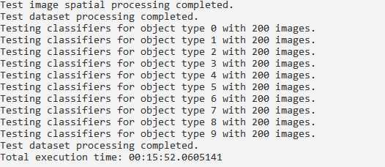
Figure 14: Total Execution time

This runtime evaluation shown in figure 14 provides evidence of the computational efficiency of our approach given the dataset size and hardware constraints. Although 15 minutes is acceptable for this scale, further optimizations (such as parallel processing or algorithmic enhancements) could significantly reduce execution time for larger datasets or real-time applications. The code below demonstrates the implementation within our program.cs.
// Start the stopwatch to measure total runtime
Stopwatch stopwatch = Stopwatch.StartNew();
// Stop the stopwatch after all processing is complete
stopwatch.Stop();
Console.WriteLine("Total execution time: " + stopwatch.Elapsed);
// Optional: wait for user input to keep the console open (for debugging)
Console.ReadLine();

Listing 13. Program.cs

IV. Conclusion
This study proposed a hybrid image reconstruction framework that combines K-Nearest Neighbors (KNN) and Hierarchical Temporal Memory (HTM) classifiers to enhance reconstruction accuracy. The evaluation results clearly show that the combined approach outperforms the individual classifiers, offering more robust and accurate image reconstruction.
In this work, the process began with preprocessing raw images, which were converted to binary and vectorized. After extracting features using spatial pooling, both the KNN and HTM classifiers were trained and tested on the Fashion MNIST dataset. The KNN classifier, which focused on pixel-level similarities, showed a competitive binary similarity of 87.00%. However, it lagged behind HTM in vector similarity, which achieved 85.90%. HTM's strength in capturing high-level feature representations was evident, as it outperformed KNN in this metric.
The fusion of the KNN and HTM classifiers resulted in the highest reconstruction accuracy. The combined model achieved an average vector similarity of 86.22% and a binary similarity of 88.12%.
This demonstrates the power of combining both classifiers: HTM excels in high-level feature extraction, while KNN contributes significantly to pixel-wise reconstruction accuracy. The fusion approach thus maximizes the strengths of each classifier, leading to more precise image reconstruction.
These findings confirm that the hybrid framework not only improves the overall accuracy but also enhances the robustness of the reconstruction process. In the future, additional optimizations to the fusion method, as well as testing with larger and more diverse datasets, could further improve the system’s ability to reconstruct complex image data. Additionally, incorporating other classifiers or fine-tuning the parameters of the existing models could further enhance performance, making the approach even more adaptable to various image reconstruction tasks.
Future work:
Despite the overall success of the hybrid model, the case study of image 8_9137—a low-contrast grayscale handbag with subtle white outlines—revealed significant limitations in current reconstruction methods, with similarity scores as low as approximately 50% across individual classifiers and the fusion approach. Future research should focus on addressing these shortcomings by investigating advanced preprocessing techniques (such as adaptive binarization and contrast enhancement) to improve the quality of feature extraction from low-contrast images.
Additionally, expanding both the training and test datasets to include a wider variety of image types and more challenging cases will be critical. Incorporating datasets with diverse characteristics (e.g., images with varying contrast levels, textures, and complex backgrounds) could provide more insights into the behavior of the classifiers and guide further optimizations.

V. References:
- Pokorný, J. (2017). Big data storage and management: Challenges and opportunities. In Environmental Software Systems. Computer Science for Environmental Protection: 12th IFIP WG 5.11 International Symposium, ISESS 2017, Zadar, Croatia, May 10-12, 2017, Proceedings 12 (pp. 28-38). Springer International Publishing.
- Chen, X., Wang, W., & Li, W. (2012, June). An overview of Hierarchical Temporal Memory: A new neocortex algorithm. In 2012 Proceedings of International Conference on Modelling, Identification and Control (pp. 1004-1010). IEEE.
- Cui, Y., Ahmad, S., & Hawkins, J. (2017). The HTM spatial pooler—A neocortical algorithm for online sparse distributed coding. Frontiers in computational neuroscience, 11, 111.
- Cui, Y., Surpur, C., Ahmad, S., & Hawkins, J. (2016, July). A comparative study of HTM and other neural network models for online sequence learning with streaming data. In 2016 International joint conference on neural networks (IJCNN) (pp. 1530-1538). IEEE.
- Abu Alfeilat, H. A., Hassanat, A. B., Lasassmeh, O., Tarawneh, A. S., Alhasanat, M. B., Eyal Salman, H. S., & Prasath, V. S. (2019). Effects of distance measure choice on k-nearest neighbor classifier performance: a review. Big data, 7(4), 221-248.

